Resources for Service

Books:

Chittister, Joan. The Gift of Years: Growing Old Gracefully. Bluebridge: New York. 2008. Note: Chapter on Outreach, page 195.

Martin, William. The Activist’s Tao Te Ching. New World Library: Novato CA. 2016.

Palmer, Parker. On the Brink of Everything: Grace, Gravity & Getting Old. Berratt – Koelher: Oakland CA. 2018. Note: Chapter V, Keep Reaching Out: Staying Engaged with the World, pages 115 -143.

Articles

1. Kitchen Table Transformation by Lynne Iser; 3rd Act Magazine, pp 18-19; Spring 2017. Available at:

https://issuu.com/3rdactmagazine/docs/3rdact_spring2017

2. In the Service of Life

by Rachel Naomi Remen

In recent years the question how can I help? has become meaningful to many people. But perhaps there is a deeper question we might consider. Perhaps the real question is not how can I help? but how can I serve?

Serving is different from helping. Helping is based on inequality; it is not a relationship between equals. When you help you use your own strength to help those of lesser strength. If I'm attentive to what's going on inside of me when I'm helping, I find that I'm always helping someone who's not as strong as I am, who is needier than I am. People feel this inequality. When we help we may inadvertently take away from people more than we could ever give them; we may diminish their self-esteem, their sense of worth, integrity and wholeness. When I help I am very aware of my own strength. But we don't serve with our strength, we serve with ourselves. We draw from all of our experiences. Our limitations serve, our wounds serve, even our darkness can serve. The wholeness in us serves the wholeness in others and the wholeness in life. The wholeness in you is the same as the wholeness in me. Service is a relationship between equals.

Helping incurs debt. When you help someone they owe you one. But serving, like healing, is mutual. There is no debt. I am as served as the person I am serving. When I help I have a feeling of satisfaction. When I serve I have a feeling of gratitude. These are very different things.

Serving is also different from fixing. When I fix a person I perceive them as broken, and their brokenness requires me to act. When I fix I do not see the wholeness in the other person or trust the integrity of the life in them. When I serve I see and trust that wholeness. It is what I am responding to and collaborating with.

There is distance between ourselves and whatever or whomever we are fixing. Fixing is a form of judgment. All judgment creates distance, a disconnection, an experience of difference. In fixing there is an inequality of expertise that can easily become a moral distance. We cannot serve at a distance. We can only serve that to which we are profoundly connected, that which we are willing to touch. This is Mother Teresa's basic message. We serve life not because it is broken but because it is holy.

If helping is an experience of strength, fixing is an experience of mastery and expertise. Service, on the other hand, is an experience of mystery, surrender and awe. A fixer has the illusion of being causal. A server knows that he or she is being used and has a willingness to be used in the service of something greater, something essentially unknown. Fixing and helping are very personal; they are very particular, concrete and specific. We fix and help many different things in our lifetimes, but when we serve we are always serving the same thing. Everyone who has ever served through the history of time serves the same thing. We are servers of the wholeness and mystery in life. The bottom line, of course, is that we can fix without serving. And we can help without serving. And we can serve without fixing or helping. I think I would go so far as to say that fixing and helping may often be the work of the ego, and service the work of the soul. They may look similar if you're watching from the outside, but the inner experience is different. The outcome is often different, too.

Our service serves us as well as others. That which uses us strengthens us. Over time, fixing and helping are draining, depleting. Over time we burn out. Service is renewing. When we serve, our work itself will sustain us.

Service rests on the basic premise that the nature of life is sacred, that life is a holy mystery which has an unknown purpose. When we serve, we know that we belong to life and to that purpose. Fundamentally, helping, fixing and service are ways of seeing life. When you help you see life as weak, when you fix, you see life as broken. When you serve, you see life as whole. From the perspective of service, we are all connected: All suffering is like my suffering and all joy is like my joy. The impulse to serve emerges naturally and inevitably from this way of seeing.

Lastly, fixing and helping are the basis of curing, but not of healing. In 40 years of chronic illness I have been helped by many people and fixed by a great many others who did not recognize my wholeness. All that fixing and helping left me wounded in some important and fundamental ways. Only service heals.

© 1996

Rachel Naomi Remen

Noetic Sciences Review, Spring 1996

http://www.rachelremen.com/service.html

Being of Service
“When we give cheerfully and accept gratefully, everyone is blessed.” ― Maya Angelou
Today in meditation we activate the sense of service. But instead of approaching service in the conventional sense, as a sort of obligation, we will look at it from the perspective of higher states of consciousness. In this view, service is not only a humanitarian effort, it is a path of joy and self-realization. It is an opportunity to grow in happiness, not a duty.
Service is listening and acting in response to a call for the unique gifts your life offers. This call is not based on your ego needs, nor does it come from social expectations. The call to service comes from your universal self, the cosmic part of you that directs your spiritual evolution or dharma. This is why being of service to the world is really a joyful expansion of the self.
Deepak Chopra

"How wonderful it is that nobody need wait a single moment before starting to improve the world." ― Anne Frank
Today we delve more deeply into what it means to be of service. When we serve others from a place of love, we are also serving ourselves.
For many of us, when we think of service, we envision great feats, sacrifices, large philanthropic donations, and other grand gestures. While service can be all those things, it can also be much more accessible in our daily lives. Giving to others through service is simply recognizing what you do best in any given moment and offering that as a gift to someone else. For instance, today you may notice someone who looks like they could really use a warm smile and, in that moment, you offer a smile in service to brighten their day. Giving can be that simple.
Deepak Chopra
Reflection
Qualities of Sages in Service

A Journal Reflection on the Qualities of Sages In Service

1. Which qualities are most important in your life today?

2. Which qualities of service do you bring now that you didn’t 10-20 years ago?

3. Where is my “leading edge?” Which quality is my challenge today?

A Contemporary Human Life Cycle
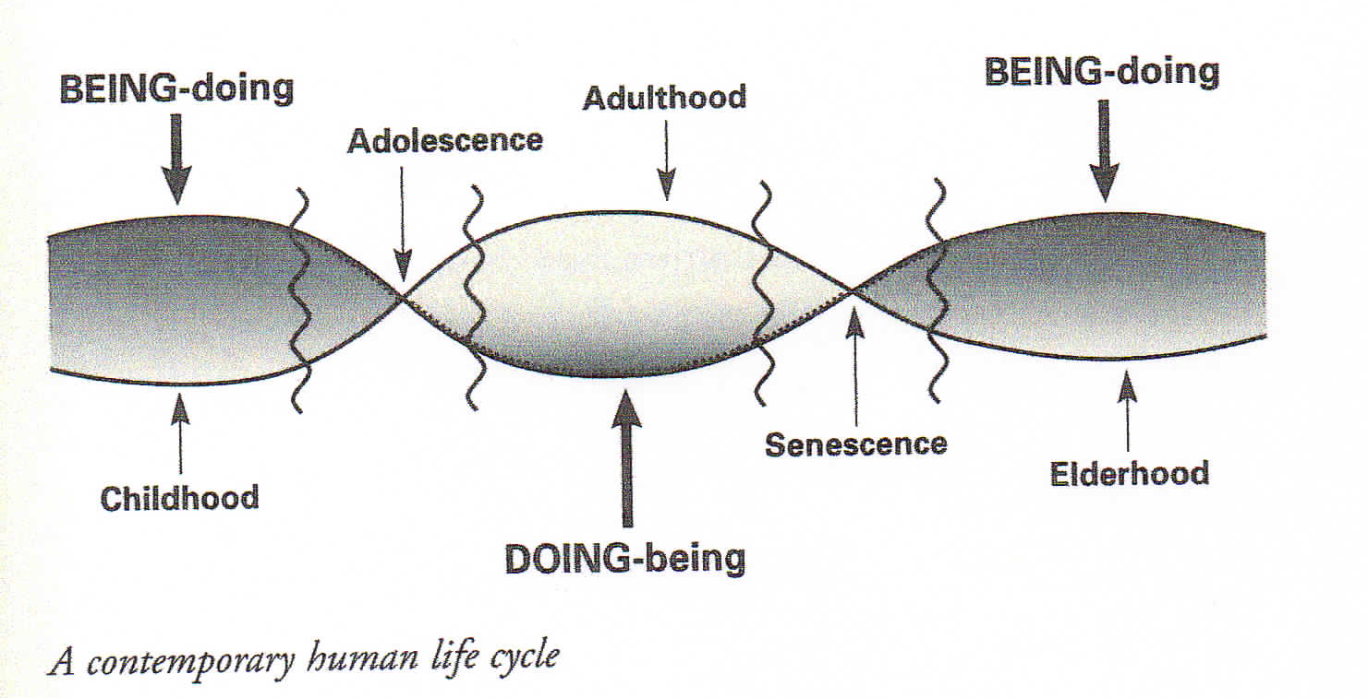

From: What are Old People For?: How Elders Will Save the World by Bill Thomas, MD

The Journey
Song by Bob and Sheila Atchley, 1996
https://www.iheart.com/artist/bob-atchley-497135/songs/the-journey-12221819/

Some folks see themselves as just a body with a mind
But the consciousness “I AM” is a key to other doors
Within each “I AM” lies the great source of all being

Light from within, that’s our illumination
To dwell in silent peace, that’s our meditation
To see the passing world with clearness and compassion

And when we clearly see, we are drawn to Be Love and to Serve
And when we clearly see, we are drawn to Be Love and to Serve

To be here now, and not just in our minds
Means seeing what we see, free of judgments, please
To know what others need, we must clearly see

Light from within, that’s our illumination
To dwell in silent peace, that’s our meditation
To see the passing world with clearness and compassion

And when we clearly see, we are drawn to Be Love and to Serve
And when we clearly see, we are drawn to Be Love and to Serve

