Resources

The Emerging Elder – Module 13
Elders as Healers of the World – Module 8

Books:

Bolton, Anthony and Pevny, Ron. The Inner Work of Eldering: Itineraries from the Spirituality of Later Life Series. Second Journey Publications, Chapel Hill NC. 2011.

Hillman, James. The Force of Character: And the Lasting Life. Ballantine Books, NY. 2000.

Hollis, James. Living an Examined Life: Wisdom for the
Second Half of the Journey. Sounds True. Boulder CO. 2018

Levine, Stephen. A Year To Live: How to Live This Year as If It Were Your Last. Random House, Inc. NY. 1998.

Martin, William. The Sage’s Tao Te Ching. The Experiment, LLC: New York. 2000.

Murphy, John S. and Hudson, Frederic M. The Joy of Old: A Guide to Successful Elderhood. Geode Press: Altadena CA. 1995.

Robinson, John C. The Divine Human: The Final Transformation of Sacred Aging. O-Books: Laurel House, Station Approach, UK. 2016.

Rohr, Richard. Falling Upward: A Spirituality for the Two Halves of Life. Josey-Bass: San Francisco CA. 2011.
Singh, Kathleen Dowling. The Grace in Aging: Awaken as You Grow Older.

The Oxford Book of Aging: Reflections on the Journey of Life. (1994). Edited by T.R. Cole & M. G. Winkler. Oxford University Press. New York, New York.

Weber, Robert L. and Orsborn, Carol. The Spirituality of Age: A Seeker’s Guide to Growing Older. Park Street Press: Rochester VT. 2015

Zweig, Connie. The Inner Work of Age: Shifting from Role to Soul. Park Street Press: Rochester, VT. 2021

Connie's blog: https://medium.com/@conniezweig
Poetry:

BECOMING AN ELDER

Leaving behind my journey of struggling and racing through
the white water of many rivers, I become the river,
creating my own unique way.

Leaving behind my self-imposed role as a tree upon
which others have leaned, I now become the wind,
with the freedom to blow whenever and wherever I choose.

Leaving behind the boxes I’ve created in my life, crammed with
roles, responsibilities, rules and fears,
I become the wild and unpredictable space
within which wild flowers sprout and grow.

Leaving behind the years of yearning for others
to see me as somebody,
I soften into becoming my future,
with permission from SELF to
continually unfold as I choose, without concern
for how others may see me.

Leaving behind years of telling and teaching,
I become instead a mirror
into which others can peer and
view reflections of themselves to consider.

Leaving behind the urge to provide answers for others,
I become – in the silence of this forest retreat
– the question.

Leaving behind the rigor of my intellect,
I become a single candle in the
darkness, offering myself as a beacon for others
to create their own path.

I become an elder.

Cathy Carmody
August 2012
Sea to Sky Retreat, BC Canada

The Map You Make Yourself
by Jan Richardson

You have looked at so many doors with longing,
Wondering if your life lay on the other side.

Foe today, choose the door
that opens to the inside.

Travel the most ancient way of all:
The path that leads you to the center of your life.

No map, but the one you make yourself.
No provision, but what you already carry
And the grace that comes to those
who walk the pilgrim’s way.

Speak this blessing as you set out
And watch how your rhythm slows,
The cadence of the road
drawing you into the peace that is your own.

Eat when hungry.
Rest when tired.
Listen to your dreaming.
Welcome detours as doors leading to deeper in.

Pray for protection.
Ask for the guidance you need.
Offer gladness for the gifts that come
and then let them go.

Do not expect to return by the same road.
Home is always by another way
and you will know it not
by the light that waits for you

but by the star that blazes inside you,
telling you
where you are is holy
and you are welcome here.

Quotes

Joseph Campbell

The gift you carry for others is not an attempt to save the world but to belong to it.
It’s not possible to save the world by trying to save it.
You need to find what is genuinely yours to offer the world before you can make it a better place.
Discovering your unique gifts to bring to your community is your greatest opportunity and challenge.
The offering of that gift - your true self – is the most you can do to love and serve the world.
And it’s all the world needs

From Rachel Freed’s Legacy Tips and Tools
September 2018
http://www.life-legacies.com/

Music

ANTHEM
Leonard Cohen

https://www.youtube.com/watch?v=6wRYjtvIYK0

SEARCHING FOR SOUL
Music and Lyrics by Bob Atchley

https://www.youtube.com/watch?v=y0Rtz4BvfeM

I went today to find my soul - it was away.
I went today to find my soul - it was away.

I looked in my car
I looked in my yard
I looked on the 2nd floor
I looked out my backdoor.

I went today to find my soul - it was away.
I went today to find my soul - it was away.

I looked in my head
I looked under my bed
I looked in a book
I looked at a picture I took.

I went today to find my soul - it was away.
I went today to find my soul - it was away.

I sat on the floor
Then, I sat some more.
I looked way deeper in me
There was my soul just as sure as could be.

I went today and found my soul - deeper in me.
I went today and found my soul - deeper in me.

Atchley, Bob (2010). Life Lessons. Parker CO: Summit Road Studio.

Websites

Spirituality and Practice

https://www.spiritualityandpractice.com

Diagrams:

From: What are Old People For?: How Elders Will Save the World by Bill Thomas, MD

A Contemporary Human Life Cycle
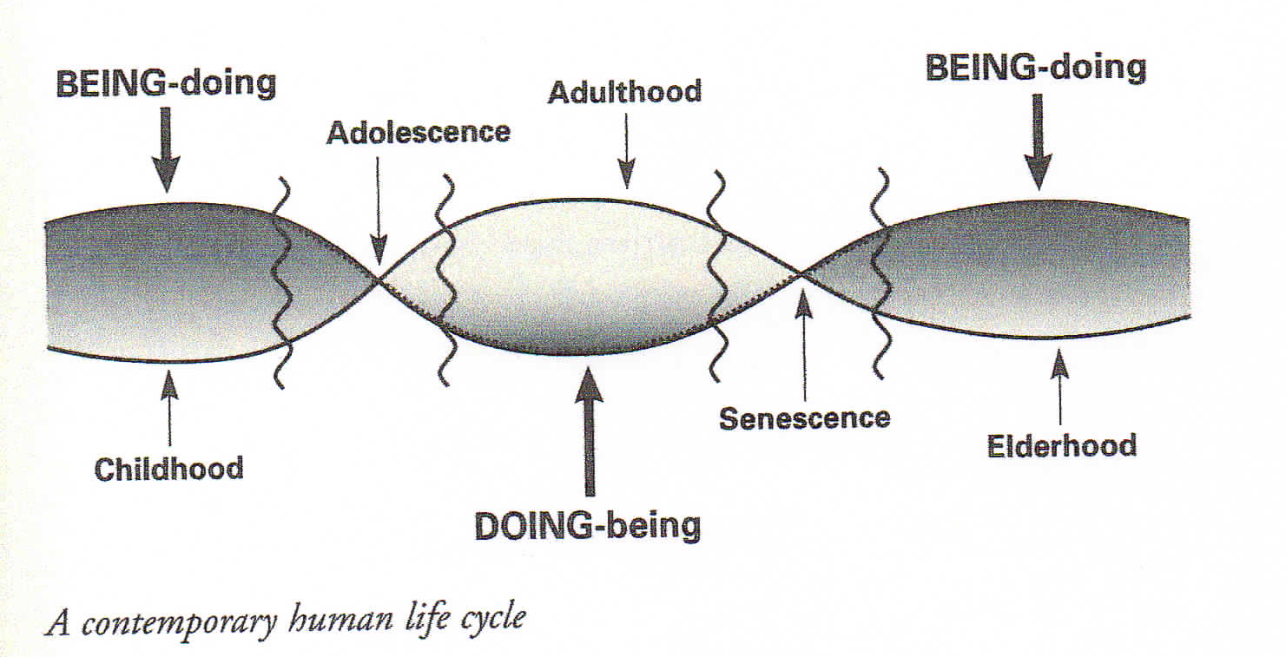

From The Joy of Old (pg 103):

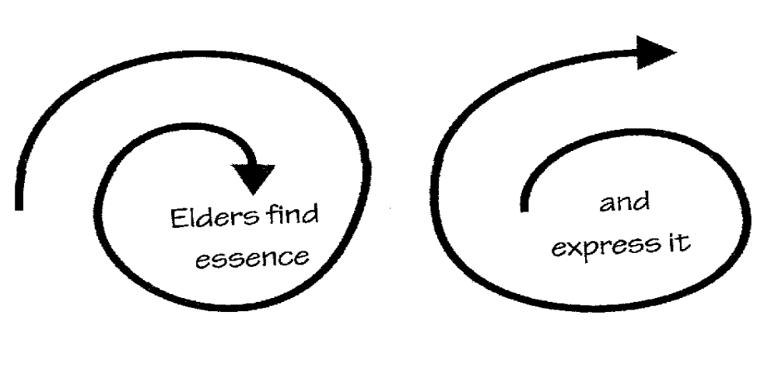

Videos

Dr. Thomas R. Cole, Keynote Speaker, American Gerontological Association Annual Meeting https://www.youtube.com/watch?v=mHXJyW9-6v4

Elders as Healers

Elders Action Network https://eldersaction.org/

Elders Climate Action https://www.eldersclimateaction.org/

Environmental Voter Project

GIZMODO.com – https://gizmodo.com/creating-our-legacies-the-elders-fighting-for-climate-1842705508

Sunrise Movement

To Repair the World: Paul Farmer Speaks to the next Generation. (2013). By Paul Farmer edited by Jonathan Weigel. University of California Press. Berkley, CA.

U.S. Climate Strike https://strikewithus.org/

15 Brave Organizations Fighting to Save Our Oceans
https://www.marineinsight.com/environment/15-brave-organisations-fighting-save-oceans/

Water Ethic: Curt Meine in Conversation with Josephine Mandamin [Sacred Water Walks] https://www.youtube.com/watch?v=zwStzuCwRtM

Water Walkers: Walking Lake Superior by Carol Ann Trembath [This is a children’s book].

Gaia “Readers Digest” Notes

…Excerpts from Reb Zalman’s From Age-ing to Sage-ing

Chapter 9; pp 211-238

p.226
Advice of Leon Shenandoah, a Native American spiritual elder: “Spiritual consciousness is the highest form of politics…Every human being has a sacred duty to protect the welfare of our Mother Earth.

p. 229
We must relate to the natural world not as an economic resource to exploit, but as the life-giving source of our physical and spiritual well-being,
p. 230 We must become planetary stewards

p.231
Berry & Brian Swimme The Universe Story – “To preserve the economic viability of the planet must be the first commitment of the medical profession. To preserve the natural world as the primary revelation of the divine must be the basic concern of religion…The well-being of the Earth is primary. Human well-being is derivative.”

p. 232
Earth is a living organism, not a piece of dead matter hurling through space around the sun. In 1975, English scientist James Lovelock in his book Gaia – A new Look at Life on Earth came up with this Gaia Hypothesis. He named this living organism Gaia, after the Greek earth goddess who was worshipped as the mother of all living beings.

p.233-234
As an organism, the earth breathes through the rain forests, which are her lungs. Because of us, she is suffering from emphysema. Her bloodstream is the planet’s lakes, rivers, and oceans. We all know what we’ve done to them. We need to restore her to health. Humanity makes up Gaia’s nervous system and brain. We are linked through a worldwide information system so we are like a huge “global brain.” Each of us is an individual nerve cell.
The planet becomes aware of itself through us. We are the eyes and ears of the world. Thus, we can recognize a hole in the ozone layer and playful dolphins in the ocean.

p. 235
We need to develop a universal solidarity to care for our earth. We need to shift our identity beyond human family to include the non-human world. We do this by broadening our sense of identity to include other animals, We have feelings for our mother earth and her failing health. It’s called compassion. Now, we must move beyond that and take social action. Pp. 236-7
- Participate as elders in intergenerational support groups united by a common environmental concerns, such as recycling, planting trees, protecting the local water supply., or combating world hunger.
- Practice a lifestyle that puts the well-being of the earth first.
- Acquaint ourselves with the mystics of the Western tradition. Matthew Fox writes that peace on earth cannot happen without peace with the earth and peace among all earth creatures.
p. 238
As spokespersons for Gaia and her many peoples, we as elders must “hold the field” for a world of sane consumption, social justice, and spiritual renewal based on celebrating the sacred within the natural world.

Compiled by Kathleen Jensen and J Sue Henry
Class of 2018

Updated January 14, 2022

